SMARTROUTE
Urban Emergency Road Routing System

Sample Execution Outputs and Test Case Results:

Test Case 1 - Display City Road Network
Objective: To display all available locations and connecting roads with their respective travel times.

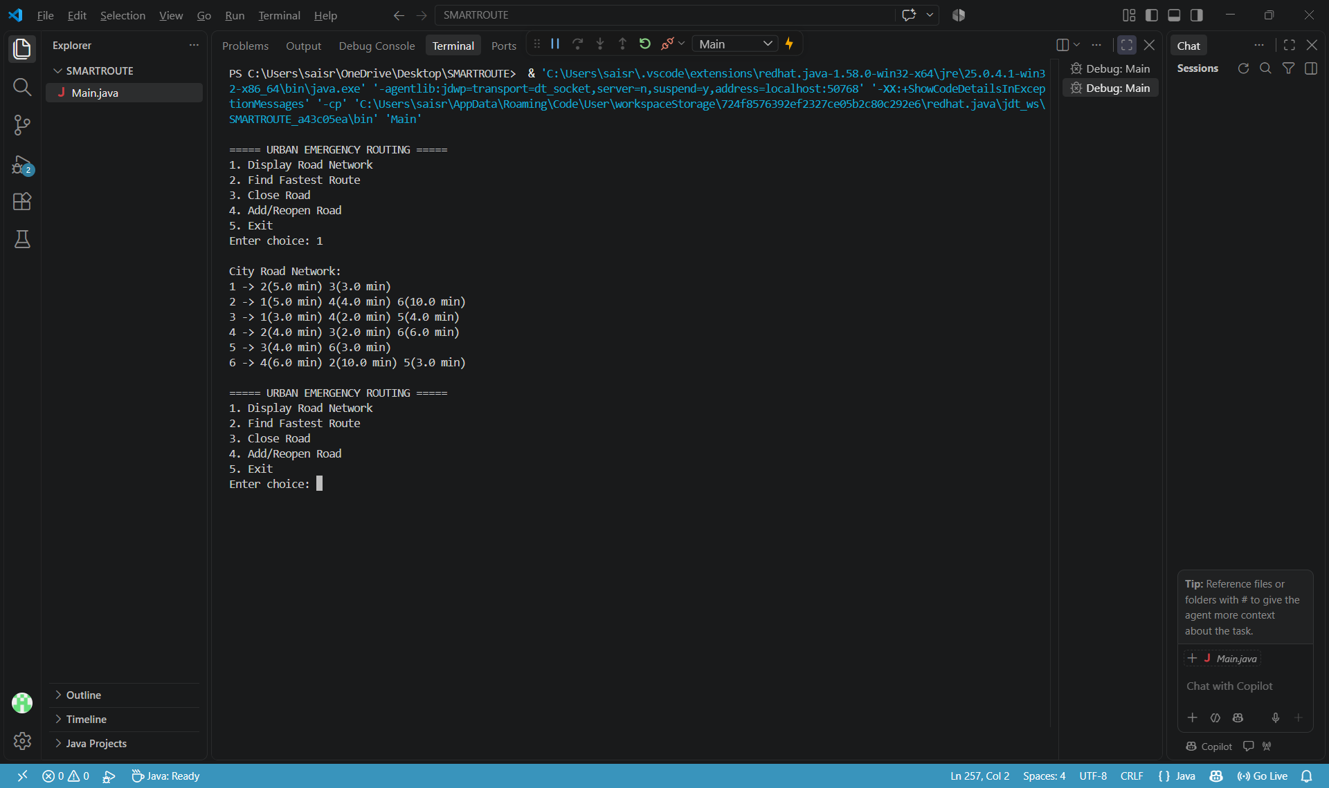

2. Test Case 2 - Find Fastest Emergency Route
Objective: To calculate the fastest route from the hospital to the accident location using Dijkstra's algorithm.
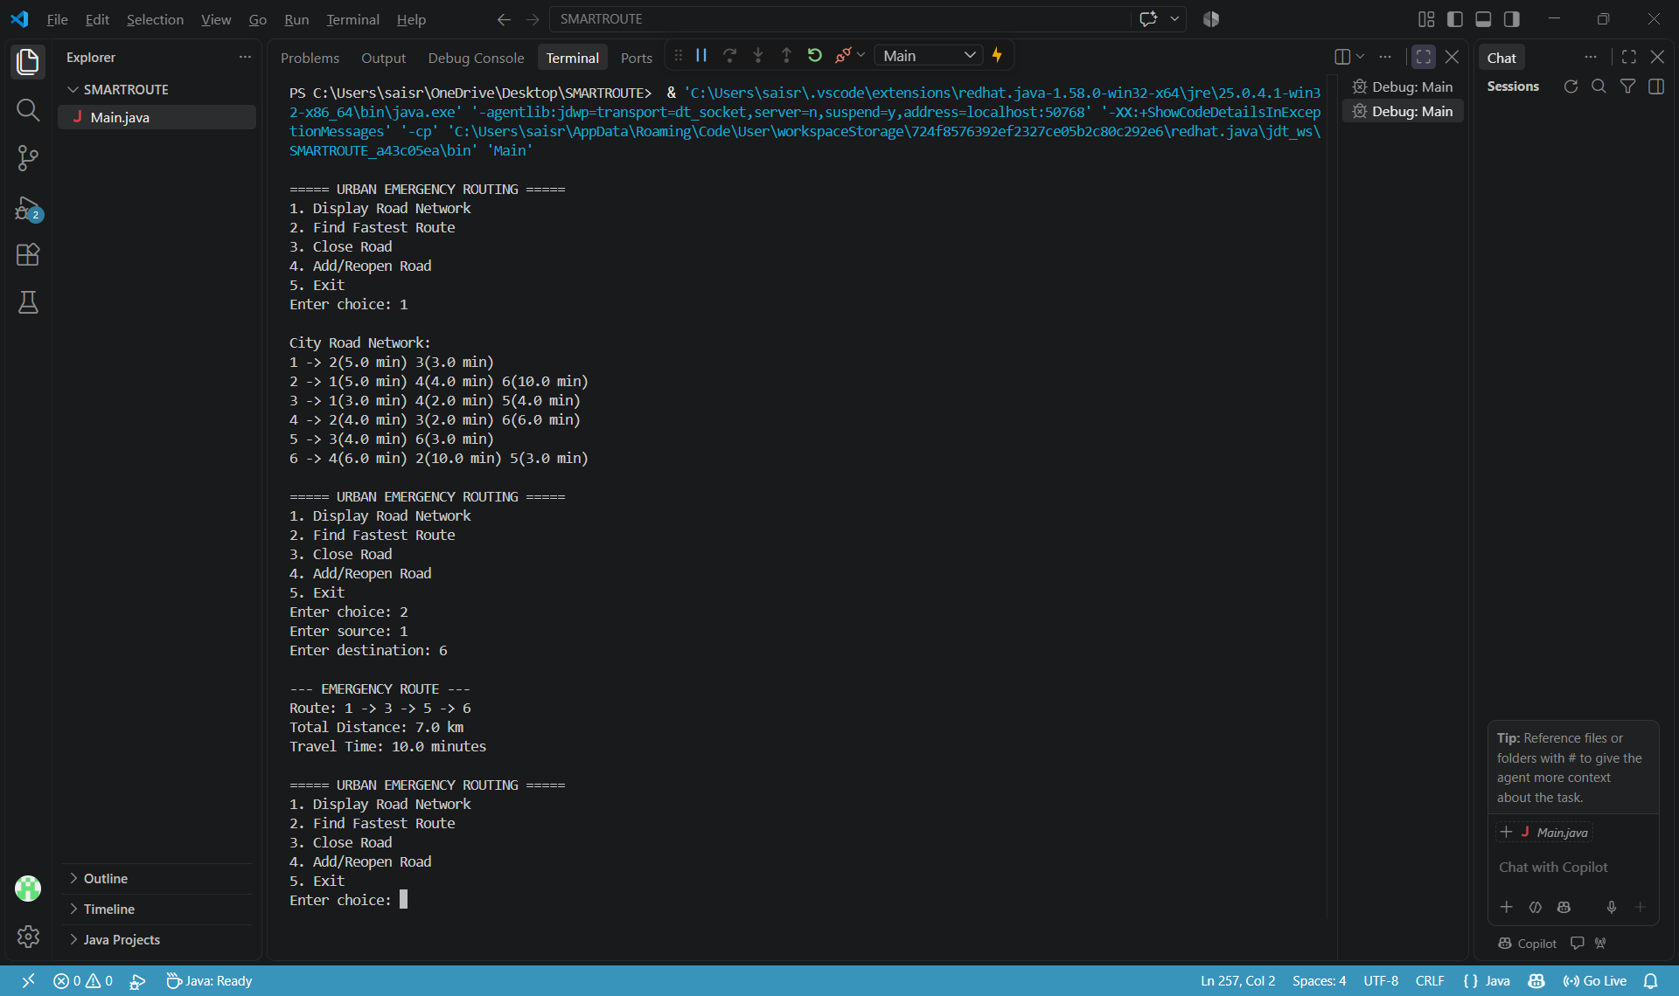

3. Test Case 3 - Road Closure Simulation
Objective: To simulate a road closure and remove the selected road from the city road network.
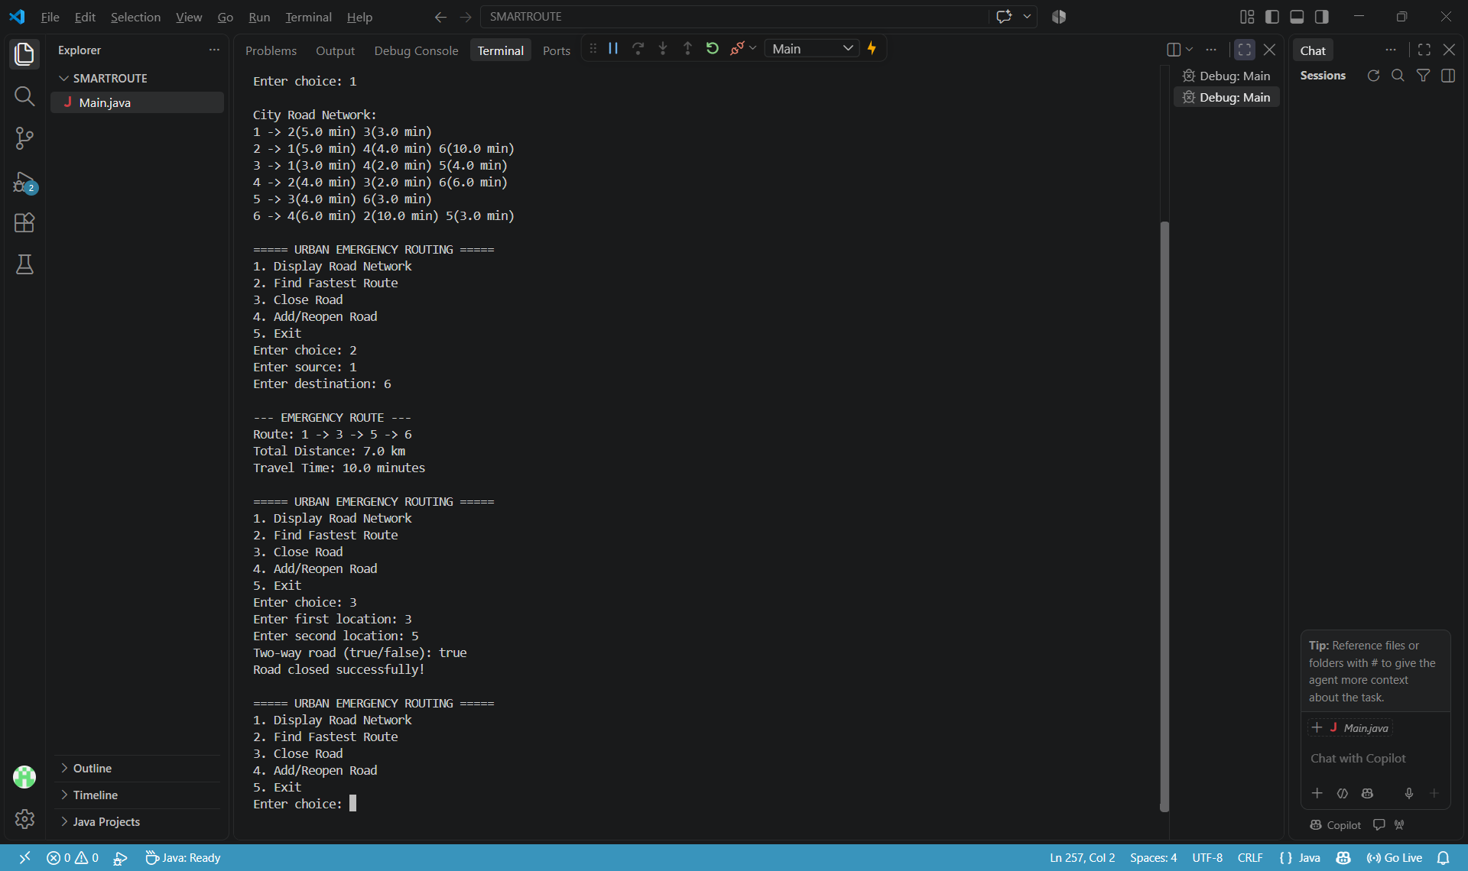

4. Test Case 4 - Road Reopening
Objective: To restore a previously closed road and update the available road network.

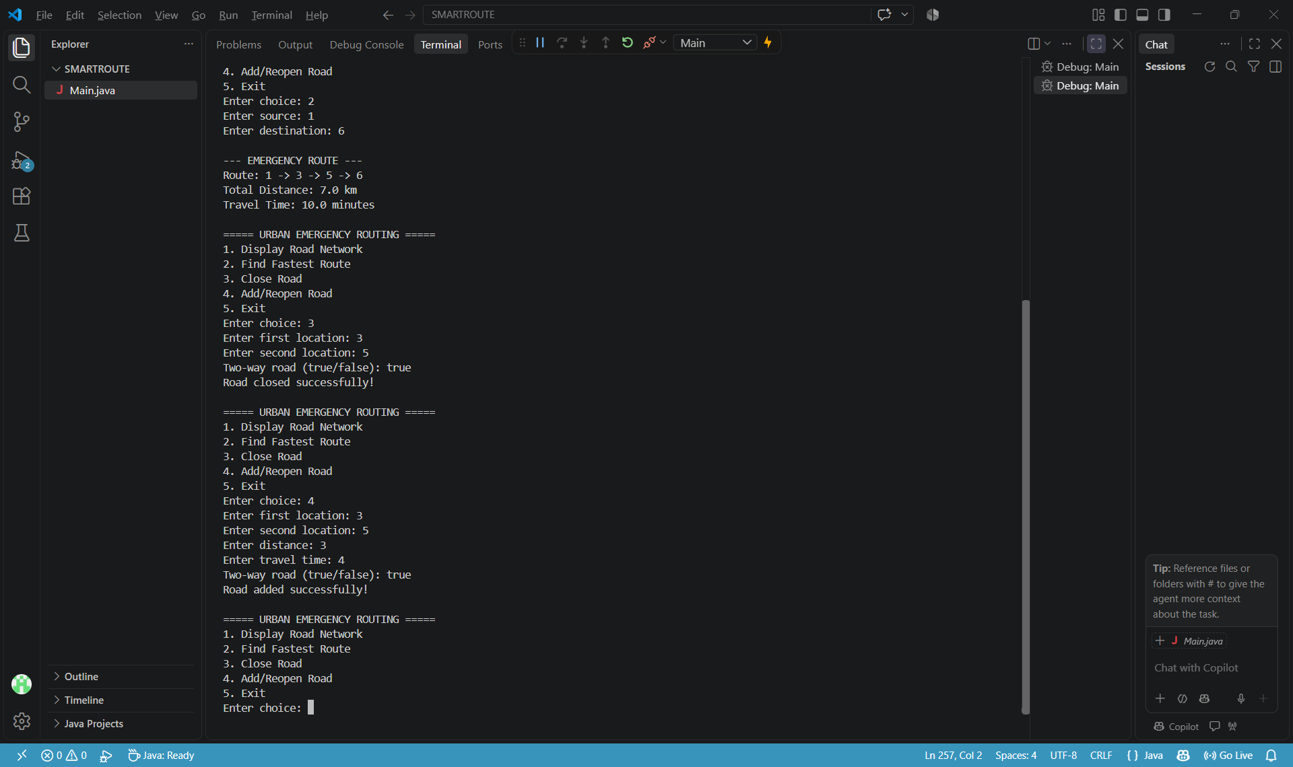

5. Test Case 5 - One-Way Road
Objective: Verify that the system respects one-way road restrictions.

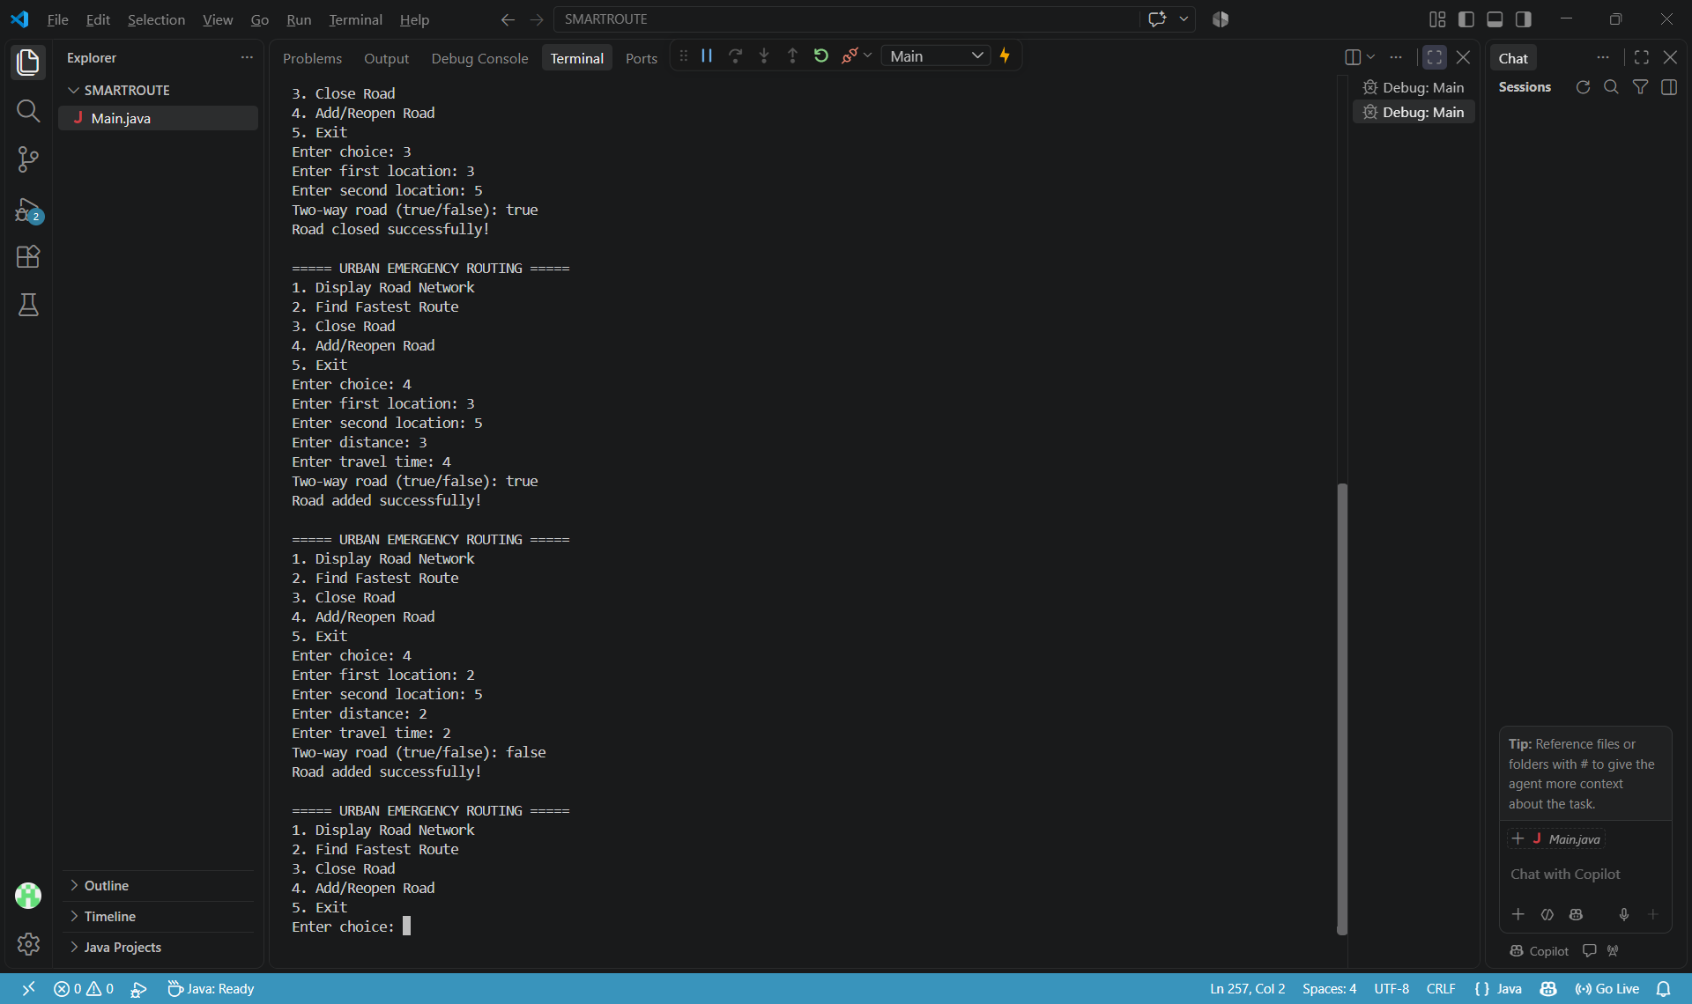

6. Test Case 6 - No Available Road
Objective: Test what happens when the destination cannot be reached.
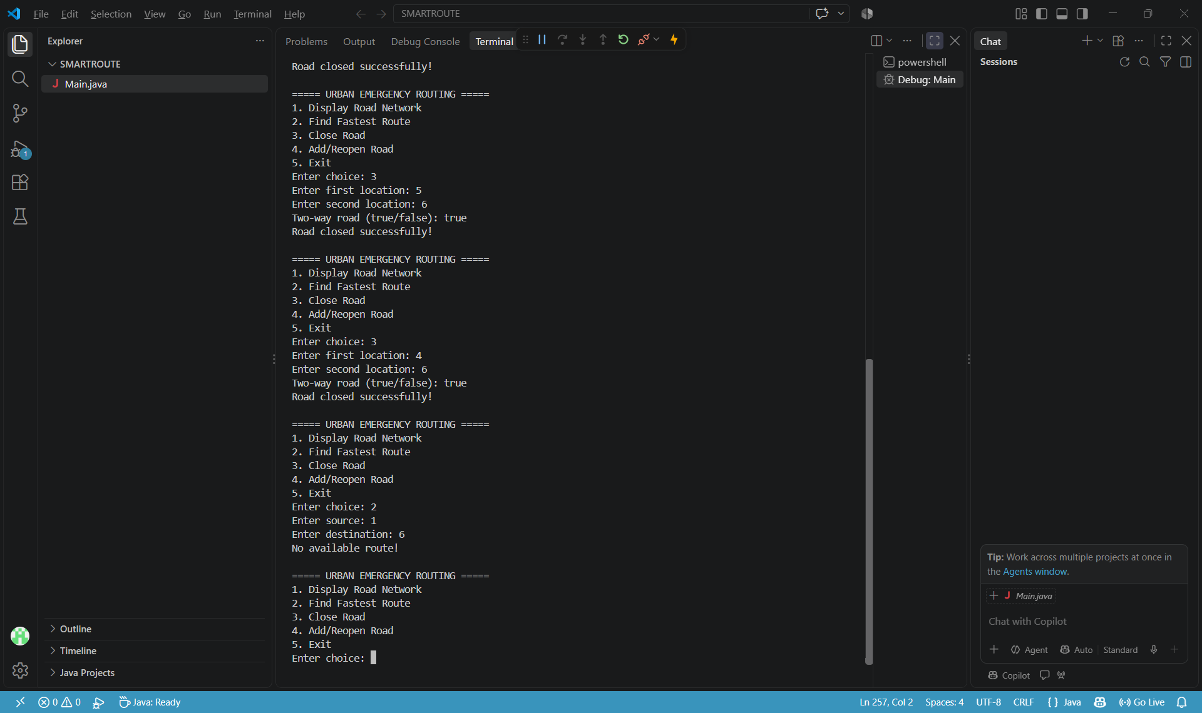

7. Test Case 7 - Invalid Source or Destination
Objective: Verify that the system handles invalid locations.
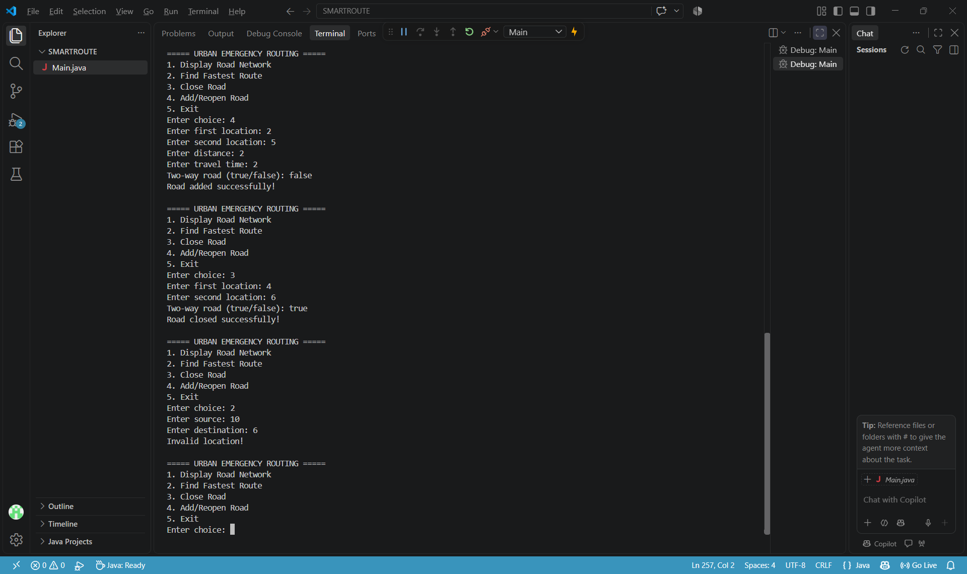

8. Test Case 8 - Invalid Menu Choice
Objective: Check whether the program handles incorrect menu selections.

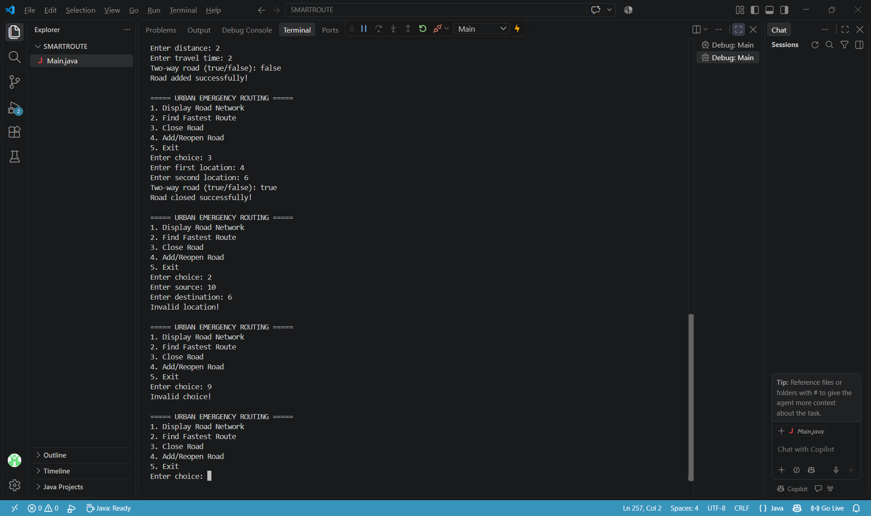

9. Test Case 9 - Exit the Program


